**DAILY ONLINE ACTIVITIES SUMMARY**

|  |  |  |  |  |  |  |  |
| --- | --- | --- | --- | --- | --- | --- | --- |
| **Date:** | **28/06/2020** | | | | **Name:** | **Anusha. K** | |
| **Sem & Sec** | **4th SEM 'A' Section** | | | | **USN:** | **4AL18CS009** | |
| **Online Test Summary** | | | | | | | |
| **Subject** | | **No test** | | | | | |
| **Max. Marks** | |  | | **Score** | |  | |
| **Certification Course Summary** | | | | | | | |
| **Course** | **Data science with python** | | | | | | |
| **Certificate Provider** | | | **greatlearning academy** | **Duration** | | | **11.5 hours** |
| **Coding Challenges** | | | | | | | |
| **Problem statement: Given a string,Find the longest substring which is palindrome using java.** | | | | | | | |
| **Status: completed** | | | | | | | |
| **Uploaded the report in Github** | | | | **yes** | | | |
| **If yes Repository name** | | | | [**https://github.com/anusha20219/Lockdown-coding**](https://github.com/anusha20219/Lockdown-coding) | | | |
| **Uploaded the report in slack** | | | | **yes** | | | |

ONLINE TEST DETAILS: no test

**C**ertification course details: Today I attended certification course on the topic Data Science with Python.

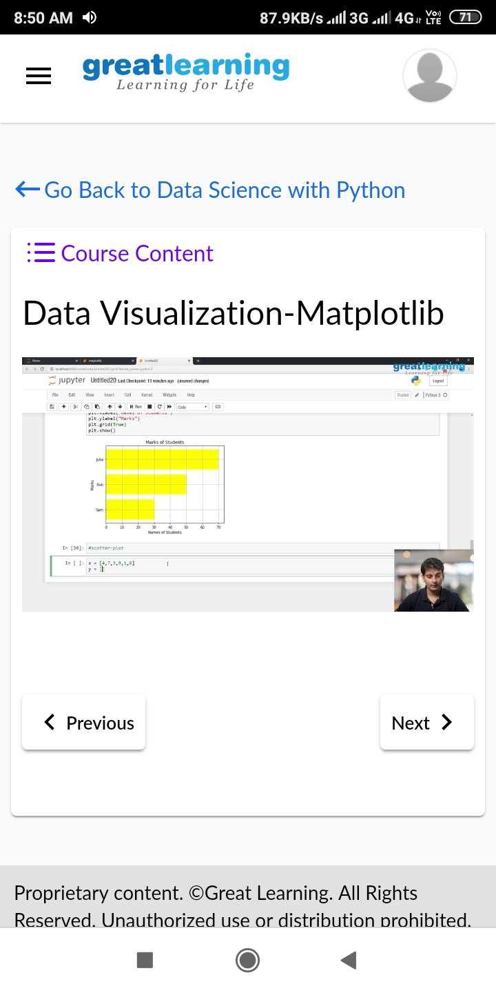

Coding challenge details:

Problem statement:

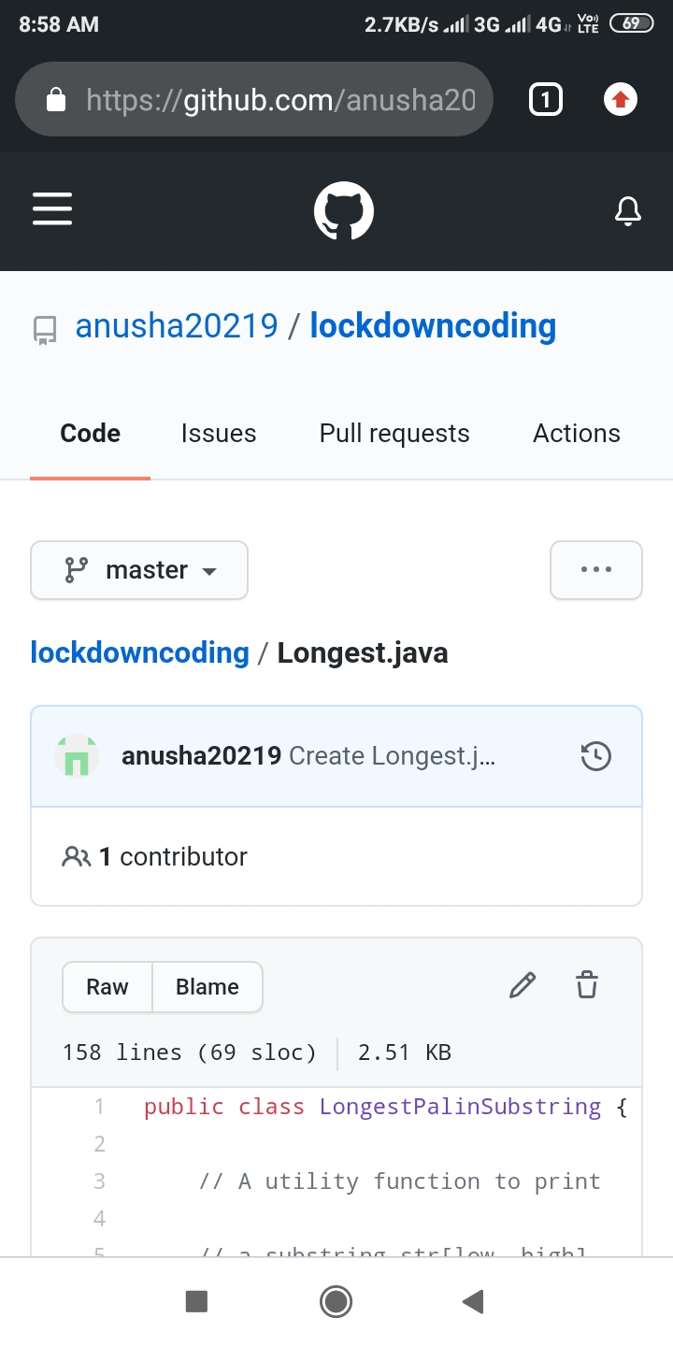Given a string,Find the longest substring which is palindrome using java.